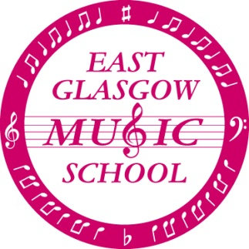

SUMMER CONCERT

We will be holding our annual Summer Concert on

Saturday 19th May 2018
9.45am – 11.45am (approx.)

This is an opportunity for all children to bring along their parents, family and friends to see what we’ve been working on throughout the year. The choirs, orchestra and recorder group will all be performing, and some of the children will be playing individually.

We never charge for tickets to our concerts, although our famous yellow buckets will make an appearance at the end of the morning, and we would be very grateful for any donations you are able to make.

Donations for raffle prizes would be very welcome and should be brought to Music School on Saturday 12th May. Please note that any donations of alcohol must be brought by an adult.

Please can all children be at the school at 9.15am. School uniform of shirt and tie should be worn.

On arrival, children should report to the following rooms:

Orchestra (Strings) Cello Room
Orchestra (Wind/Brass) Recorder Room 1
Recorder Group Recorder Room 2
Choirs Gym Hall

We look forward to seeing you all on May 19th.

THE MUSIC SCHOOL TUTORS

**Remember it's not too late to get your tickets for our Ceilidh at Mount Vernon Community Hall tonight (28th April). They are available at the tuck shop or on the door.**

